On load website:

1. **Expected Action:** Display list of all popular leagues/teams and players along with a list of live matches
2. 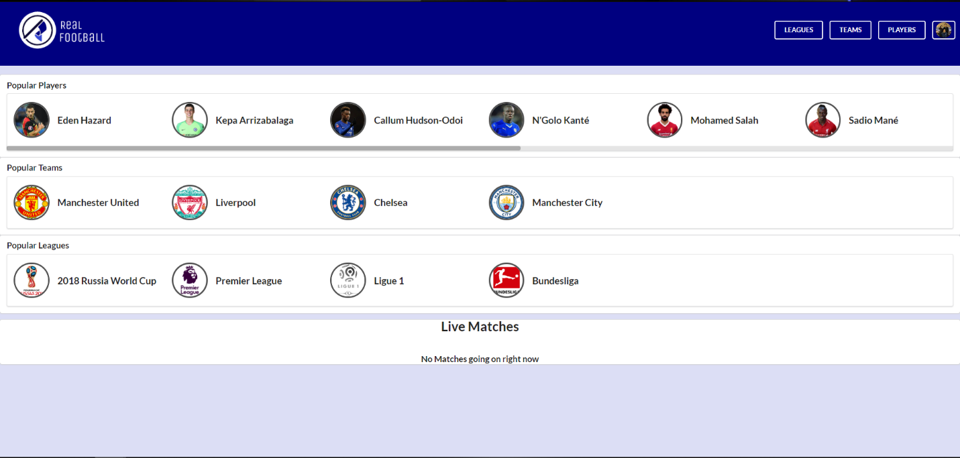**Actual Action:**

On clicking Sign In button in header

1. **Expected Action:** Take user to Sign In page where they can log in using their Facebook account
2. 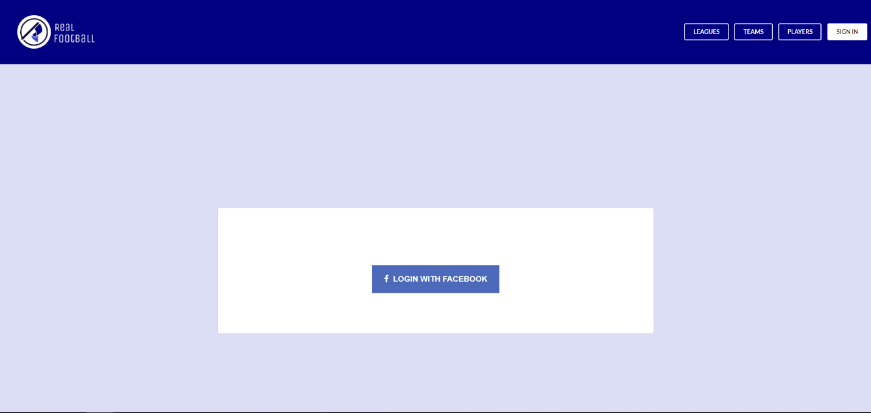**Actual Action:**

On clicking login with Facebook button

1. **Expected Action:** Show user external popup to login with their Facebook Account
2. 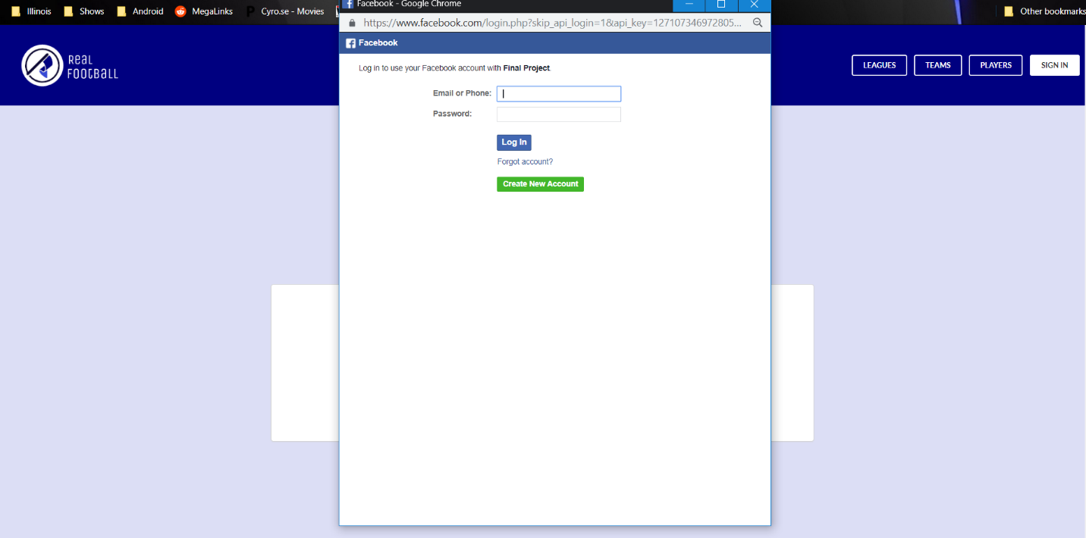**Actual Action:**

On signing in

1. **Expected Action:** Change Sign in button to button with users Facebook image, clicking which would lead to the users profile page which includes their name, email and a list of their favourite teams, leagues and players
2. 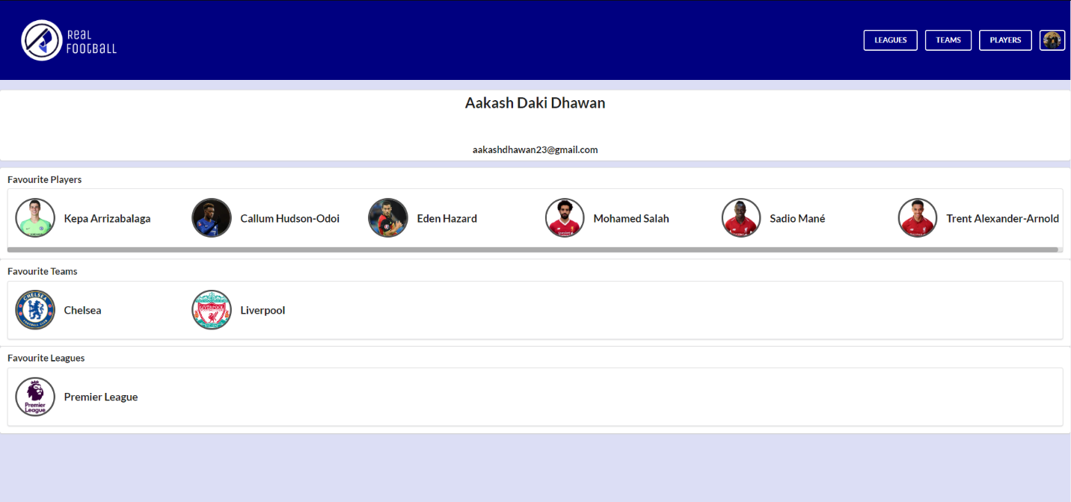**Actual Action:**

On clicking header button

1. **Expected Action:** Take the user to the corresponding page and highlight selected button
2. 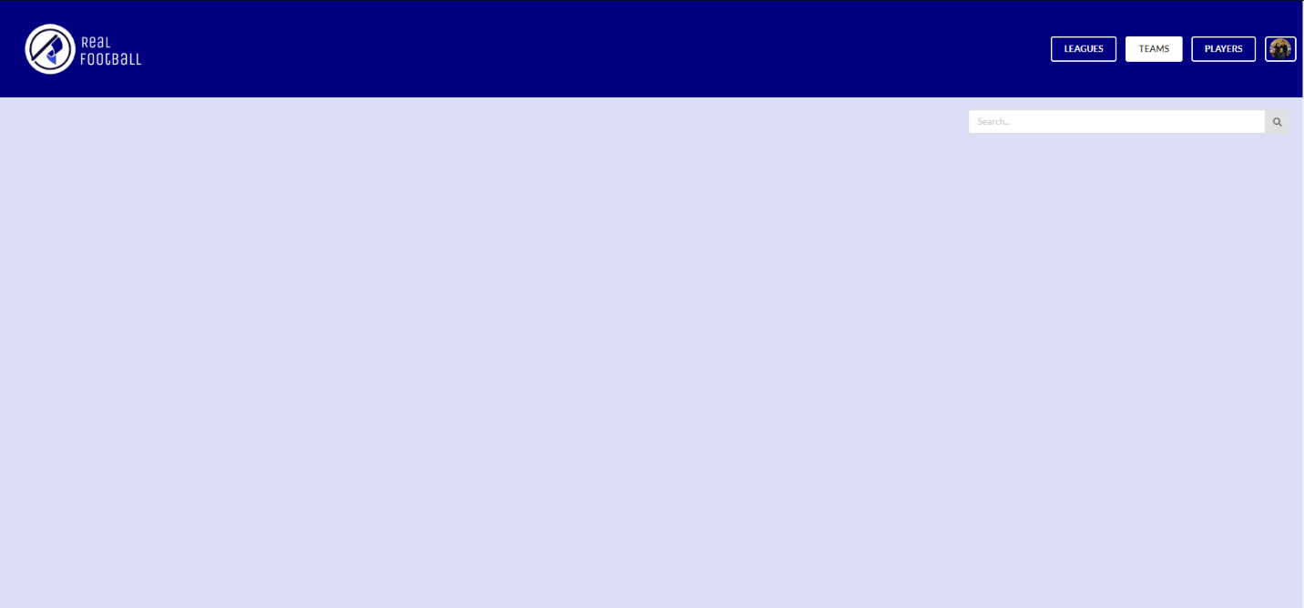**Actual Action:**

On clicking on team

1. **Expected Action:** Take user to particular teams page and highlight the team in the team standings
2. 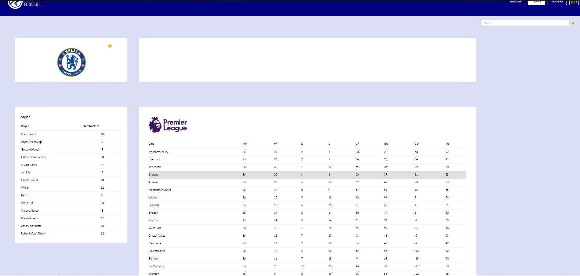**Actual Action:**

After signing in, give user option to favourite their choices of leagues, teams and players

1. **Expected Action:** Show star at team, league, player pages to allow user to favourite them
2. 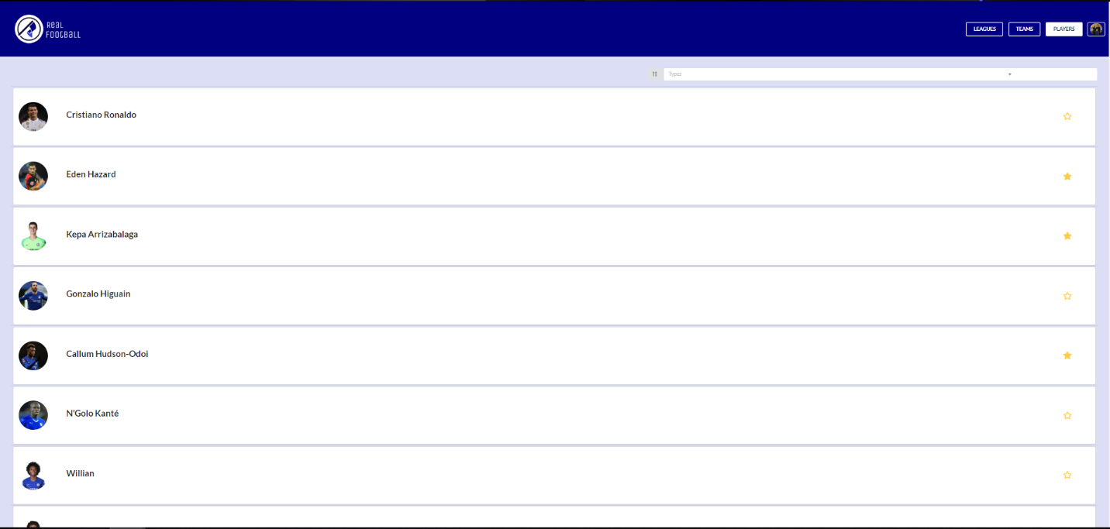**Actual Action:**